Benefit Comply
Impact Analysis Tool

Supervisor User Guide
- Upon receipt of the Analysis Tool, you should receive,
- Health Impact Analysis Tool
- Word Template for the Impact Analysis Report
- Census Template for Collecting Employee Census Data
- Employer Plan Data Template for Collecting Employer Plan Information
- Supervisor User Guide
- Saving Original Impact Analysis Tool and Word Template
First, you must set up a file folder or network location where you want to store your original copy of the Impact Analysis Tool and Word Template. Generally the files should be saved on a shared drive in a folder where all users will have access to the tool. However, depending on the firm’s network structure the files could also be saved in spate individual workstations for each user. Please discuss the best arrangement for your system with your Benefit Comply representative.
  - Saving Original Word Template-This document should not be opened! The Word Template name must not be changed or else the analysis tool will not be able to input data into the template when producing a report. When MS Word opens a template it opens as a Word Document and cannot be saved as a template of the same name.
    - Right click on the Word Template file name and select “copy”
    - Go to the file folder where you would like to store the word template. This folder should be accessible to any computer that will be using the tool.
    - Right click and select “paste” to copy the template into the proper directory
- Saving Original Impact Analysis Tool
    - Save in file folder you set up to store the original version of the Tool. Once the tool is set up, you may distribute copies to any computer that can access your shared network.
- Data Requirements: The Tool requires two sets of data in the proper format in order to run the calculations. If the data is not formatted correctly for the tool to run properly.
  - No cells can be left blank
  - The data must be in the format described below (e.g. “M” for married and “S” for single)
  - Employee Census Data: Only employees working 30 hours or more per week should be included in the census
  - The eight data elements of the census be provided in the proper sequence as follows:
emp_id gender plan_no coverage m_status comp hours class
    - emp_ id
      - Employee Identifier- Any unique numerical identifier-Do not use SSN or other individually identifiable data such as name or birth date. It must not be left blank.
    - gender
      - Enter either M for male or F for female only.
    - plan_no
      - Enter the plan number under which the individual is covered -this number must match the number on the Employer Plan Chart template
        - 0=no plan, 1=Low Cost Plan*, 2,3,4=other plans- Note - the lowest cost plan must be plan 1
*The Low Cost Plan is determined by the Employee’s cost for single coverage, not based on the total premium for the plan.
    - Coverage
      - Enter the coverage level maintained by the employee
0 = not enrolled in health plan
1 = single
2 = tier 2 coverage
3 = tier 3 coverage
4 = tier 4 coverage
5 = family
    - m_status
      - Enter an M for married or an S for single only (Any other letter in this column will cause an error message when uploading the census).
        - Domestic partners covered by the plan should still be entered as single in the marital status field even in states that allow same sex marriage.
    - comp
      - Enter total estimated annual compensation-this must be an annualized comp estimate not the actual amount paid to the employee for the 12 month period. For example – an employee that was only employed 3 months during a 12 month period and was paid a total of $10,000 during the 3 months would have an annualized income of $40,000.
    - hours
      - Enter the average number of hours worked per week for all employees that work 30 or more hours per week. Part-time employees working less than 30 hours should not be included.
        - Enter 40 for exempt employees or any full time employees for which the employer does not track hours
        - Use an estimate based on the most recent 12 month period available
    - class
      - There must be a consistency between census data and employer plan information. Due to the number of variables being considered (class, plan number, coverage level) it is very important to make sure the census data aligns properly with the plan information in the system.
      - The census must contain a class number for each individual that corresponds to the class in the plan information. There should never be a “0” in this column.
        - The low cost plan (based on what the employee pays for single coverage) must be plan number 1 for EACH class.
          - In cases where the employer has different contribution rules for different classes of employees, each class could have a different low cost plan.
  - Employer Plan Data – Expanded Employer Data Template
    - Employer Information
      - Estimated Participation Rate of Newly Eligible Employees
        - This number should reflect an estimate of the percentage of employees that are newly eligible for health care, due to the reform, that will participate.
      - % of current employer contribution estimated as additional income
        - This percentage estimates what percentage of the current employer contribution the employer would give if they stopped offering coverage
      - Effective Corporate Tax Rate
        - Enter best estimate of the employers corporate tax rate
Default numbers are set for these categories, but they will vary greatly between clients.
    - Insurance plan tiers – the program allows for 5 different rate tiers for each plan.
      - Tier 1 needs to be the employee only coverage tier
      - Tier 5 needs to be the family coverage tier
      - Tier 2, 3 and 4 can be used for other rate definitions such as employee+child or employee+spouse.
        - If there is only single and family, tiers 2, 3 and 4 can be left empty.
    - Employee Classes

      - There are now up to 6 different employee classes. The census must contain a class number for each individual that corresponds to the class in the plan information. Separate classes could be set up for a variety of reasons:
        - Different plans offered to different groups of employees
        - Different employer contributions
        - Classes of full time employees ineligible for benefits

      - Each class of employee can have up to 5 different benefit plans

        - This new class structure allows you to model changes in scenario 2 based on making changes to just one class of employees. For example – “ What would happen if we increased the employer contribution by $50 for the hourly employee class”, or “what would happen if we made an ineligible class of employees eligible for the plan”

    - Insurance Plans –
      - The low cost plan (based on what the employee pays for single coverage) must be plan number 1 for each class. In cases where the employer has different contribution rules for different classes of employees, and/or where different plans are available to different classes, each class could have a different low cost plan. It is critical that, for each class, the low cost plan be determined, and that the low cost plan be designated as Plan 1 for all employees in that class—both in the employee census and in the employer plan data
Consistency between census data plan information

Due to the number of variables being considered (class, plan number, coverage level) it is very important to make sure the census data aligns properly with the plan information in the system. It will be very easy for a small mistake in the data to make the results invalid.

  - For example – The employer offers a Blue Cross PPO to both salaried and hourly employees, but the salaried employees also have a cheaper HDHP plan. The PPO would need to be Plan 1 for hourly employees, but the HDHP would be Plan 1 for the salaried employees. In both the employee census and the employer plan data, Plan 1 for the salaried employee class would be the HDHP plan, and Plan 1 for the hourly employee class would be the Blue Cross PPO plan.

Running the Impact Analysis Tool
  - Pre-Tasks
    - Open the Impact Analysis Tool
    - Click on the “Options” tab to Enable Macros
    - Select “Enable this content” when prompted
    - Enter application password
Go to “Save as” and save the workbook as a new project (i.e. Company XYZ Analysis)
  - Enter Employee Census Data
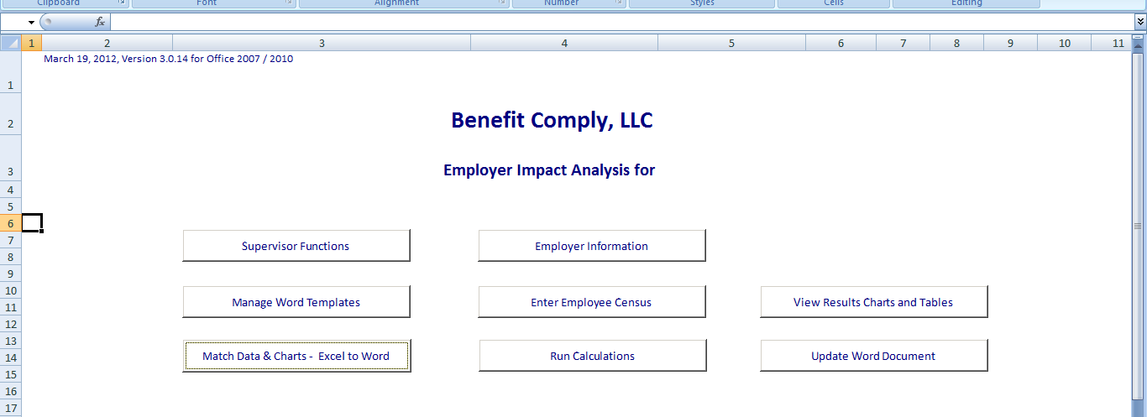
    - Click “Enter Employee Census”

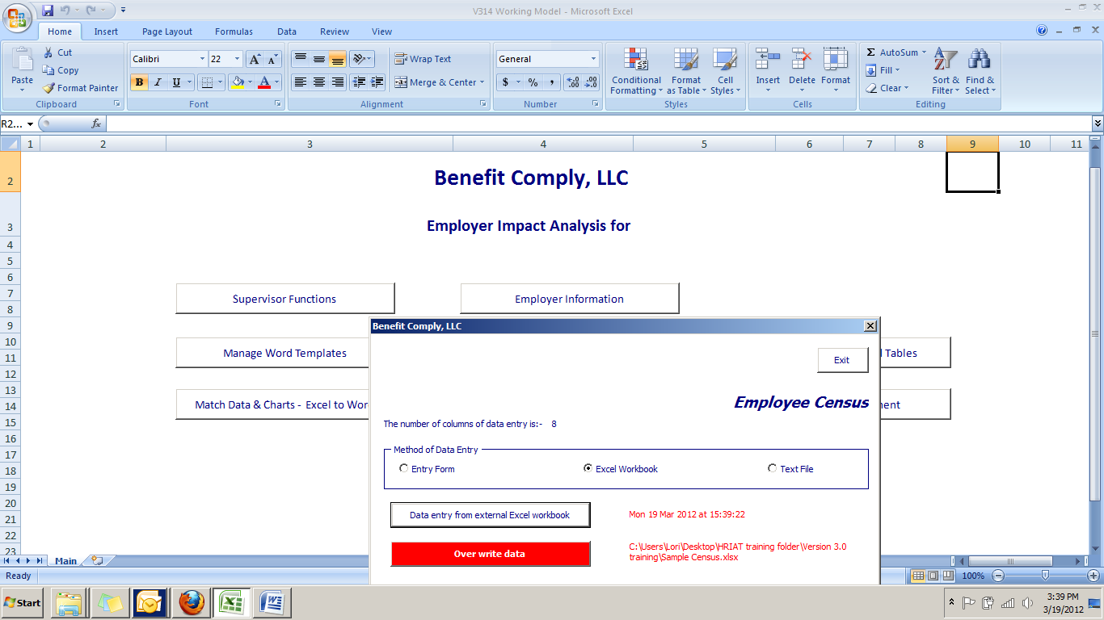
    - In the screen that pops up, choose method of entry (Most likely Excel Workbook if the employee census is in an Excel spreadsheet)
    - Leave red tab as “overwrite data”. If you click on the red tab it will switch to a green tab saying “append to existing data.” Avoid appending data unless specifically instructed to do so by a Benefit Comply representative. It is always best to upload a new census if the data needs to be changed.
    - Click on “Data entry from external Excel workbook”
    - In new screen, click “Yes” to Load Excel workbook data now
    - Find where you have stored the census file in your system and select the Excel file with the census data
    - When file has finished uploading, Exit the Employee Census screen
      - You will know the census has uploaded when you see the location appear in red in the bottom right corner of the box

- Entering Employer Plan Data
    - Click “Employer Information”
      - Enter the following:
        - Estimated participation rate of newly eligible employees
        - % of current employer contribution
        - Effective Corporate Tax Rate
      - Enter the insurance plan information for each plan the employer offers:
        - Plan 1 must be the low cost plan-This is determined by the Employee cost for single coverage. Note: In cases where the employer has different contribution rules for different classes of employees, and/or different plans are offered for different classes, each class could have a different low cost plan.
          - Self-funded plans should use COBRA premium
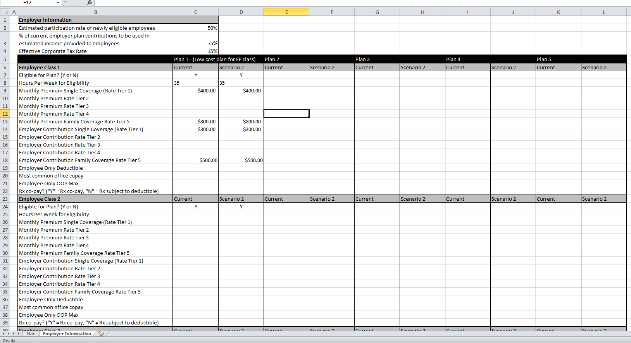
        - Enter the same data in both “current” column & “Scenario 2” column (data can be changed in Scenario 2 later when modeling the impact of a change).

    - Return to Main Page by clicking on the “Main” button at bottom of spreadsheet
- Preliminary Data Processing
    - Click the button, “Run Calculations”. In small screen that pops up, you can view the progress bar.

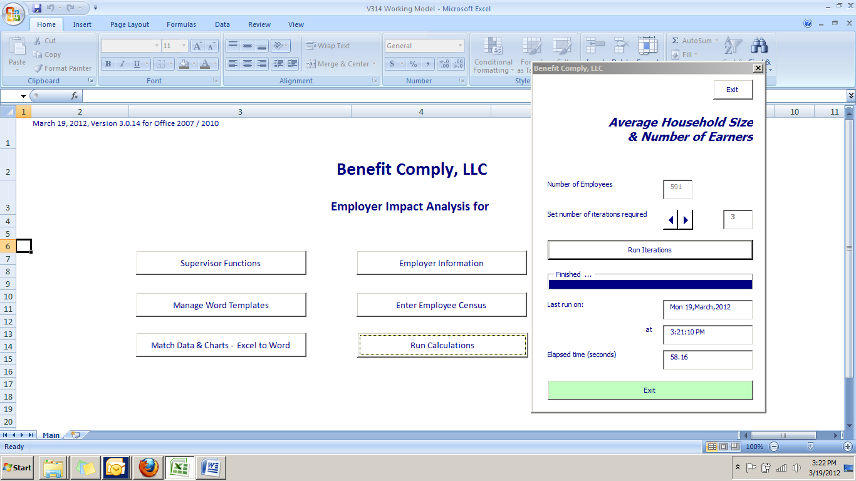
Progress Bar
      - You also have the opportunity to “set number of iterations required”. The default is set at “3” and will work for any group under 500 employees. If working with a large group over 500, set the iteration to “1” as the results will already be statistically valid and it will save you time
Note: The time it takes to run these calculations is heavily dependent on the number of employees in the census and the speed of the computer. A 7,000 employee census can be anywhere from 2 minutes on a fast computer to 35 minutes on slower one. If working with a large group, give yourself time to run these calculations.

- Processing the Report
  - Click “Update Word Doc.”
    - This will process the report showing the impact of the health reform regulations based on the data provided.
  - Save this Word document report with the name of the client and the date.
    - The word document can then be edited for final presentation.
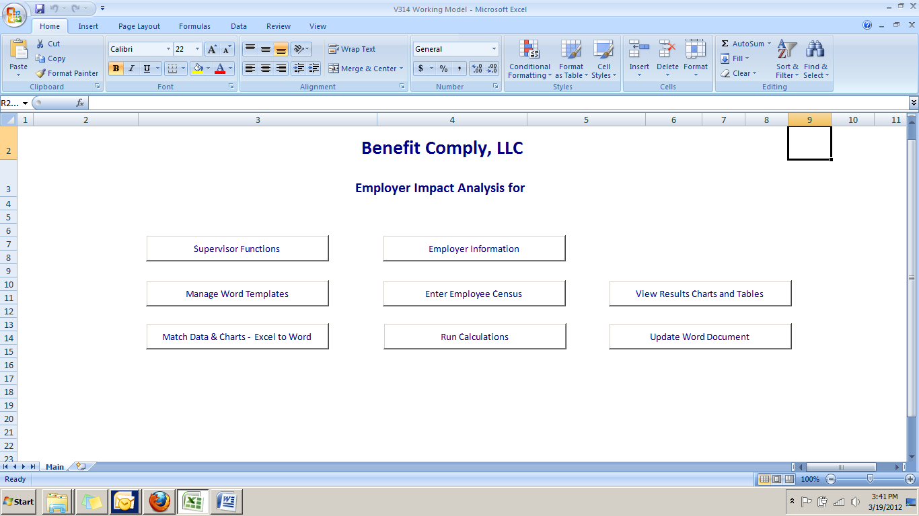

- View Excel Tables and Charts Tabs-When clicking on the “View Results Charts and Tables”, you will see a document with all of the Tables and Charts that are included in the Health Reform Analysis Report. They are separate from the report to enable easy uploading to PowerPoint presentations, and for use in other situations in which the full report is not needed. Also, when modeling the impact of plan changes, you may want to go to this tab first to see the results, before running the full word document.

