Health Reform Employer Impact Analysis

Prepared for

Sample Employer

Date

Health Reform Employer Impact Analysis

Overview

Beginning in 2014, an “applicable large employer” becomes subject to what are referred to as the “shared responsibility rules,” also often referred to as the “play or pay” rules. Generally an employer must have had at least 50 full-time equivalent employees in the previous calendar year to be subject to these rules.

Under the shared responsibility rules, an employer may be liable for an “assessable payment” (penalty) if at least one of its full-time employees purchases coverage through an exchange and qualifies for a premium tax credit or cost sharing reduction (referred to as a subsidy for the rest of this report). Full-time employees are generally defined as those working an average of at least 30 hours per week, or 130 hours per month.

Individuals with household income up to 400% of the federal poverty level (FPL) may be eligible for subsidized individual health insurance coverage when purchased through a public exchange. However, an individual is ineligible for subsidized coverage if the individual is eligible for employer-sponsored “affordable” “minimum essential coverage.” These criteria are explained in more detail below.

Note: The penalty structure is significantly different for employers who offer minimum essential coverage to all full-time employees than that which will apply if an employer decides not to offer MEC coverage. This report estimates and compares the estimated cost impact of both types of penalties.

Minimum Essential Coverage (MEC) and Minimum Value (MV)

Employee subsidies, and employer penalties, described below are dependent in part on the type and value of the health plan offered by employers to their employees. To avoid the possibility of paying a penalty, an employer must offer minimum essential coverage (MEC) with a defined minimum value (MV). An MV health plan must have an actuarial value of at least 60%.

Employee Qualification for Subsidies
Table A
2012 400% of
Federal Poverty Level
Household Size
1 $44,680
2 $60,520
3 $76,360
4 $92,200
5 $108,040
6 $123,880
7 $139,720
8 $155,560

A penalty may apply to an employer if at least one full-time employee qualifies for subsidized coverage and actually purchases coverage through an exchange. Individuals with incomes up to 400% of the federal poverty level (FPL) may qualify for subsidized coverage through an exchange.

A full-time employee who meets the income qualifications may qualify for subsidized individual coverage through a public exchange if:
- The required employee contribution for single coverage exceeds 9.5% of their household income; or
- Their employer plan does not provide minimum value.

All employees who are not eligible for an affordable minimum value plan may qualify for subsidized individual coverage if income requirements are met.

Individuals will need to apply to a state or federally run exchange to be “certified” as subsidy eligible. The employer will then be notified by the Exchange if an employee has qualified for and purchased subsidized coverage.

Employer Shared Responsibility Rules and Penalties

Under the ACA shared responsibility rules, employers may be liable for two different types of penalties.

4980H(a) Penalty - Employers who do not offer minimum essential coverage to all full-time employees
If an employer fails to offer minimum essential coverage to all full-time employees, and at least one employee is certified by the exchange and purchases subsidized coverage, the employer will pay a penalty of $166.67 per month ($2000 per year) times the total number of full-time employees including employee-offered coverage (excluding the first 30 employees).
- There are special rules on the penalty calculation for employers that are part of a control group.
- The total liability is calculated monthly based on the total number of full-time employees each month, but paid on an annual basis.

4980H(b) Penalty - Employers who offer minimum essential coverage to all full-time employees
An employer will pay a penalty of $250 per month ($3000 per year) times the number of employees who are certified by the exchange and actually purchase subsidized coverage.

The IRS has introduced 3 safe harbors regarding the employer penalty. Since employers do not typically know the employee’s household income, an employer will not pay a penalty if the required contribution for employee-only coverage meets one of the following safe harbors. Employee contribution for single-only coverage is no more than 9.5% of:
  - The employee’s wages from the employer regardless of the employee’s household income.
  - The hourly pay rate of the lowest paid full-time employees.
  - The applicable Federal Poverty Level (FPL) for a single individual.

Medicaid Eligibility

Currently Medicaid eligibility varies by state. Beginning in 2014, Medicaid eligibility is expanded nationwide to an individual whose household income is no more than 138% of Federal Poverty Level (FPL). The federal government will pay for 100% of the costs of newly eligible Medicaid recipients through 2016.

Current Medicaid eligibility rules vary significantly from state to state and now, due to the 2012 Supreme Court decision, states may individually choose whether to participate in the ACA Medicaid expansion. Consequently, the impact that Medicaid expansion will have on any particular employer will be dependent on the number of employees living in states choosing to adopt the expanded Medicaid definition.

States are expected to increase the use of the Medicaid Health insurance Premium Payment Program (HIPP). HIPP allows states to pay an employee’s contribution to an employer-sponsored health plan (if the employee is eligible). This provision may increase the number of Medicaid-eligible employees and their families enrolled in employer-sponsored plans.

Analysis Process

This Health Reform Impact Analysis Report has analyzed census data provided by the employer and uses proprietary algorithms to calculate the estimated financial impact of various provisions of the health reform legislation. The actual results an employer will experience will depend on a number of factors that are currently unknown. Actuarial and statistical assumptions were made to estimate results as accurately as possible at this time.

Many results are a function of an employee’s household income, which is not available to most employers. This report uses assumptions that take into consideration a number of factors to attempt to estimate household income. The calculation is based on census data, employee demographics, employee income level, and other factors.

Important Note:
All data provided is based on assumptions that may or may not reflect the actual behavior and choices made by individuals based on their particular circumstances. The results are designed to provide the employer with illustrations to assist in identifying the impact of various health reform changes. The report cannot predict exact financial results.

Impact of Health Reform Provisions

Full-Time Eligibility
The employer shared responsibility rules require employers to offer coverage to all employees who work 30 hours or more per week. This report analyzed the number of employees not eligible for coverage due to the employer’s current eligibility definition and estimates the additional employer cost to cover these newly eligible individuals.

Individuals working at least 30 hours a week but less than the employer’s current hours per week eligibility requirement
The analysis includes individuals listed on the employer census with average work hours of at least 30 hours per week. If average work hours were not included in the original employer census date then no cost can be estimated for these individuals.

Individuals working full time but currently ineligible for health benefits
The analysis also calculates an estimated cost for full-time employees currently ineligible for benefits based on employee classification if data on ineligible employees was provided in the initial census.

Cost estimate development
To estimate the cost impact on the employer the analysis makes the following assumptions:
- Newly eligible employees will participate in the plan at a participation rate of 50%. (The assumed participation rate can be changed to a different percentage if desired.)
- If an employer offers multiple plan options, the analysis bases the cost assumption on the employer’s low-cost plan option.
Chart 2
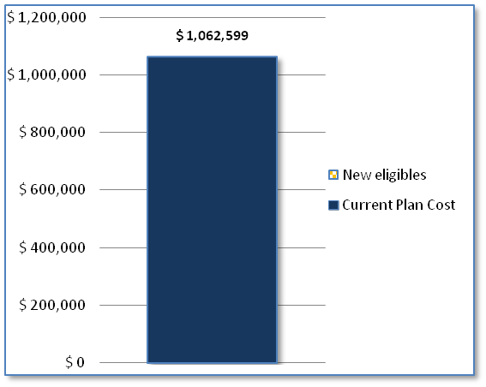
Table 2
Eligibility
Current plan eligibility (hours per week) | 40
Number of full-time employees not currently eligible | 0
Assumed participation rate for newly eligible employees | 50.0%
Current plan cost | $ 1,062,599
Plan cost of newly eligible employees | $ 0
Employer cost inc. new eligible employees | $ 1,062,599

Employer Penalty #1 Results
This employer penalty may apply when coverage is unaffordable for some employees. The following results represent the estimated maximum annual penalty risk an employer faces based on the data provided. These results assume that all individuals who are eligible for subsidized individual health insurance will leave the employer plan and purchase that coverage if its relative value is better than the employer plan. Note that actual results will depend on choices made by individual employees. It is possible employees will choose to stay on the employer plan even when eligible for subsidized individual coverage that is better than the employer plan.

Current employee required contributions for employee-only coverage in low-cost plan (Silver PPO)
- Non-tobacco user = $108.24/mo.
- Tobacco user = $121.85/mo.
- Subgroup #2 = $233.56/mo.

Table 1
Employer Statistics
Total employees | 336
Total currently participating | 203
Household income < 400% FPL | 210
Total subsidy-eligible | 9
Subsidy-eligible likely to purchase individual coverage | 9

Table 3a
Employer Penalty | Number | Current Plan Cost | Cost of Penalty | Net Cost
Subsidy-likely employees currently on employer plan | 5 | $ 17,383 | $ 15,000 | -$ 2,383
Subsidy-likely employees not currently on employer plan | 4 | $ 0 | $ 12,000 | $ 12,000
 | Total Estimated Cost |  | $ 27,000 | $ 9,617
Note: Penalty capped at $2000 times number of FTEs (not counting first 30) |  | Max. Penalty | $ 612,000

Chart 3
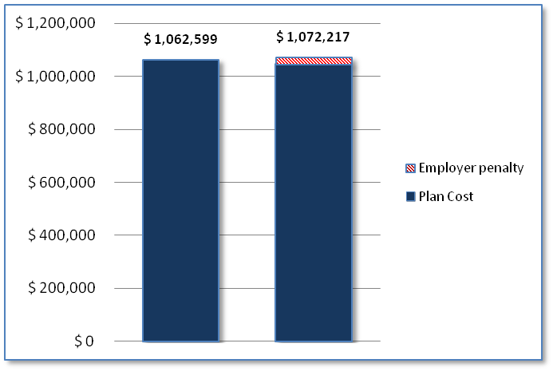
Table 3b
Summary of Impact of Shared Responsibility Penalty | Current | After ACA
Plan cost | $ 1,062,599 | $ 1,045,217
Employer penalty | $ 0 | $ 27,000
Total | $ 1,062,599 | $ 1,072,217

Alternative Scenario 2

This analysis allows for the presentation of alternative employer contributions or plan design arrangements, and estimates the effect the changes would have on expected employer costs.

In this scenario we increased the employer contribution to subgroup #2 to $350/mo., reducing the required contributions for employee-only coverage in low-cost plan (Silver PPO) to $174.57

Table 1.2
Employer Statistics | Scenario 2
Total employees | 336
Total subsidy-eligible | 0
Subsidy-eligible likely to purchase individual coverage | 0

Table 3a.2
Employer Penalty | Number | Current Cost | Cost of Penalty | Net Cost
Subsidy-likely employees currently on employer plan | 0 | $ 0 | $ 0 | $ 0
Subsidy-likely employee not currently on employer plan | 0 | $ 0 | $ 0 | $ 0
 | Total Estimated Cost |  | $ 0 | $ 0
Note: Penalty capped at $2000 times number of FTEs (not counting first 30) |  | Max. Penalty | $ 612,000

Chart 3.2

Table 3b.2
Summary of Impact of Shared Responsibility Penalty | Scenario 2 | After ACA
Plan cost including newly eligible employees | $ 1,099,372 | $ 1,099,372
Employer penalty | $ 0 | $ 0
Total | $ 1,099,372 | $ 1,099,372

Details on Determining Employees Likely to Qualify for Subsidized Coverage
This analysis compares a number of factors to estimate the number of employees likely to leave the employer plan and purchase individual subsidized coverage on the exchange:
- The cost of the employee subsidized coverage on the exchange is determined as a percentage of the individual’s household income. The analysis compared the expected cost of the exchange coverage to the required contribution for the employer plan.
- The subsidy is based on “Silver” level coverage on the exchange. This analysis compares the employer-provided coverage with a model “Silver” level plan and adjusts the likelihood that any particular individual will choose exchange coverage based on the relative value of each plan.
  - The analysis also takes into account the impact of lower income individuals who may also receive cost-sharing reductions in the form of waived deductibles and co-pays.

Notes on Results
- “Total subsidy-eligible” is the estimate of the number of current employees who will qualify for subsidized individual health insurance coverage through an exchange.
- “Subsidy-eligible likely to purchase individual coverage” takes into account the difference in plan premiums and plan designs to estimate the number of employees who are subsidy-eligible who will actually choose to purchase individual coverage through an exchange instead of participating in the employer plan.
- Employer will pay $250 per month for any employee who purchases subsidized coverage through an exchange, but if the employee is already covered by the employer plan, the employer will no longer be required to make their current employer contributions. In this case the employer will experience cost savings for these individuals that will at least partially offset the penalty the employer is required to pay.

Medicaid Eligibility
Health Reform expands Medicaid eligibility to any individual with a household income of less that 138% of FPL. The increase in the number of employees who may qualify for Medicaid could impact an employer plan significantly, depending on how aggressively any particular state uses the Medicaid Health Insurance premium Payment Program (HIPP).

Under HIPP, states are allowed to pay the employee-required contribution for any available employer plan instead of providing complete Medicaid coverage to the individual and their family. If a particular state takes full advantage of the HIPP program, there will likely be an increase in low-income employees covered by the employer plan who may currently be unable to afford the coverage. On the other hand, if a state does not choose to enroll Medicaid recipients in employer-sponsored plans, the employer may experience a decrease in costs as some currently covered Medicaid eligible employees opt out of the employer plan and choose to receive Medicaid benefits instead.

This analysis estimates the number of current employees likely to qualify for Medicaid. The system then considers how many of these individuals are currently covered by the employer plan. Finally, a cost impact range is developed.
- The maximum cost impact to the employer results from the state’s enrolling, and paying the employee contribution for, all Medicaid-eligible employees not currently covered in the employer plan.
- The maximum savings, or lowest cost impact to the employer, results from all currently covered employees who become Medicaid-eligible dropping the employer plan and choosing Medicaid coverage instead.

Actual results are likely to fall somewhere in between these outer limits. A particular employer’s results will depend largely on how many employees live in states that choose to take advantage of the expanded Medicaid eligibility rules.

Even if states enroll employees though the HIPP program, it is unlikely that they will enroll 100% of the Medicaid-eligible employees at a particular employer. Conversely, even if currently covered employees choose to opt out of the employer plan and take Medicaid coverage, it is unlikely that all eligible employees will do so. The chart and table below illustrate the range of possible cost impact for the employer.

Possible Range of Cost Impact on Employer Due to Medicaid Eligibility Changes
Chart 4
138% of
Federal Poverty Level
Household Size
1 $15,415
2 $20,879
3 $26,344
4 $31,809
5 $37,274
6 $42,739
7 $48,203
8 $53,668
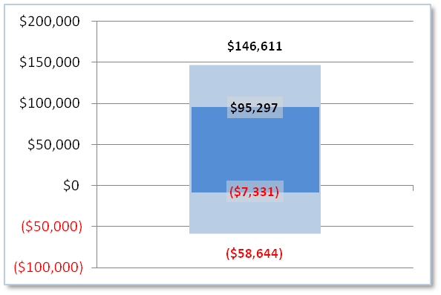
Table 4
Medicaid
Total employees | 336
Total Medicaid-eligible employees | 20
Estimated maximum cost due to Medicaid eligibility | $ 146,611
Estimated maximum savings due to Medicaid eligibility | ($ 58,644)
Estimated midpoint of Medicaid cost impact | $ 43,983

Summary of Employer Cost Impact

This page summarizes the impact of the health reform provisions considered in detail in previous sections of the report.
Chart 5
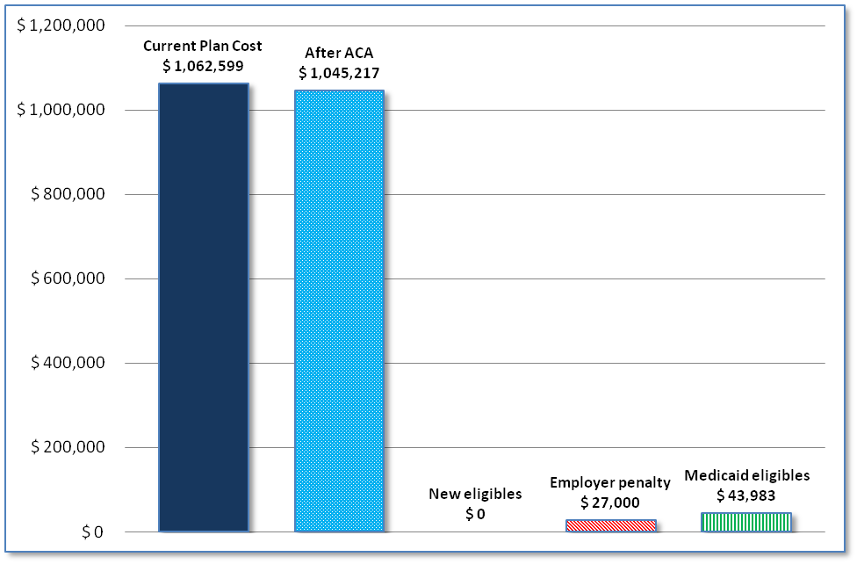
Table 5
Summary of Impact of Health Reform Provisions | Annual Cost Risk
Current plan cost | $ 1,062,599
After ACA | $ 1,045,217
New eligibles | $ 0
Employer penalty | $ 27,000
Medicaid eligibles | $ 43,983

Notes regarding this summary:
- The cost impact of each particular issue cannot always be combined to produce a “total” cost impact because in some cases there will be overlap in the risk presented by each section of the report.
  - For example, the estimate of the cost to the employer for newly eligible individuals makes assumptions about how many individuals will be eligible for the plan under new full-time eligibility rules imposed by the ACA. This estimate is intended to illustrate the potential cost to the employer of enrolling these newly eligible individuals. On the other hand, the estimate of the employer penalty risk calculates the potential cost to the employer of an employee qualifying for a subsidy. Newly eligible individuals can also potentially qualify for subsidized coverage. However, a particular employee will not qualify for a subsidy and be on the employer plan at the same time. Therefore, depending on the demographics of the group, there could be overlap between these two estimates.
- The change in plan cost illustrated here reflects the fact that under the employer current plan, if an employee leaves the plan and elects individual subsidized health coverage on the exchange, the employer will no longer be responsible for current employer contributions for that employee. Thus, the employer plan cost would go down for each currently covered employee leaving the plan. This change is reflected in detail in table 3a on page 5.
Employer Penalty for Not Offering Coverage to All Full-Time Employees

Applicable large employers who do not offer minimum essential coverage to all full-time employees are required to pay a penalty of $166.67 per month ($2000 per year) times the number of all full-time employees (not counting the first 30 FTEs).
Many employers recognize that if they stop offering health benefits to currently eligible employees, those employees may expect some increase in compensation to make up for the loss of the benefit. This analysis considers the total cost of dropping employer-sponsored health insurance, taking into account the following factors:

- The total employer penalty - Calculated based on all current full-time employees whether they are eligible for coverage or not (not counting the first 30).
- The cost of additional compensation provided to employees. The report assumes the employer will provide additional employee compensation in lieu of offering health benefits. The amount is expressed as a percentage of the total the employer spends on health insurance. The report default assumes income equal to 75% of what the employer currently spends on health insurance. This assumption can be changed on a report-specific basis.
- Additional employer payroll tax liability - Calculated based on a percentage of any additional compensation provided to employees. The report uses 7% to estimate the employer payroll tax liability since some employees will exceed the social security portion of the payroll tax.
- Corporate tax impact - The employer penalty is not tax-deductible for the employer. The report illustrates a financial impact to the employer based on an assumed corporate tax rate. The report default assumes a corporate tax rate of 15%. This assumption can be changed on a report-specific basis.

Chart 6

Table 6
Cost Impact of Not Offering Coverage to All Full-Time Employees | Current | Impact
Employer cost | $ 1,062,599 | $ 1,840,781.10
Employer penalty |  | $ 612,000
Additional compensation |  | $ 1,062,599
Employer payroll tax on additional compensation |  | $ 74,382
Tax impact of penalty not being tax deductible |  | $ 91,800

